CZ1106 Lecture NOTES

# Registers

* R0
* R1
* R2
* R3: pass argument values to return values from subroutine
* R4
* R5
* R6
* R7
* R8
* R9
* R10: local variables within subroutine
* R11: Frame Pointer (FP)
* R12: Scratchpad Register / Return Register
* R13: Stack Pointer (SP)
* R14: Link Register (LR)
* R15: Program Counter (PC)
* CPSR

# Instructions

* 0x00 to 0xFF

# Memory

* 0x100 onwards

# Lab:

x EQU 8 ;Assigns immediate value 8 to the variable x, does not store anywhere

label1 **DCD** 0x1234 ;Puts the number into **memory**, NOT registers! Also don’t need #. If at the start of

the program, label1 will store into 0x100.

**ADR** rstr, x ;Obtains the **memory address** of x and places it in rstr

NZVC flag will only be affected by –S instructions: if the next instruction doesn’t have S, the NZVC flags will remain (e.g. as 1000)

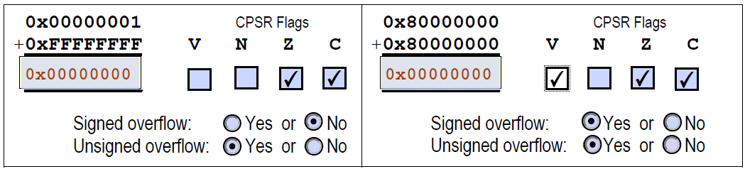

0xFF = 1 byte

0x08 == 0x8 =/= 0x80

|  |  |
| --- | --- |
|  |  |

# Big/Little Endian (Storing numbers in memory)

* Two ways, depending on the byte-ordering of data in memory: Big/Little Endian format.
  + Big Endian: number is stored from lower to higher memory address.
  + Small Endian: number is stored from higher to lower memory address.
* Only numbers are affected by the Big/Little Endian formatting!!
* 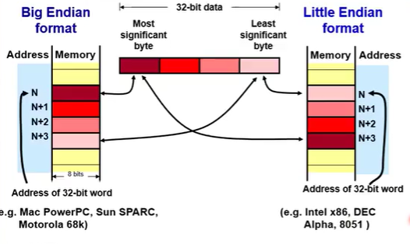

## Note: when question asks for starting address, it is still read from top-down, i.e. address N, no matter the format. This is because Little Endian simply reads from the little end (LSB) and fills them in sequentially, the number doesn’t actually fill in from the bottom.

|  |  |
| --- | --- |
| Address | Memory |
| 0x200 | 0x00 |
| 0x201 | 0x02 |
| 0x202 | 0x00 |
| 0x203 | 0x00 |

R0 = 0x00000200 || R1 = 0x12345678 || Little Endian

LDR R1, [R0]

1. [R0] refers to the memory address 0x200

### 0x200 is the starting address of the 2-byte int 0x0200, since Little Endian is used.

1. 0x0200 is copied over into R1.

# Char Representation

* Requires one byte
* Stored in binary, transformed into char through encoding standard. Most common = 7-bit ASCII

## ASCII

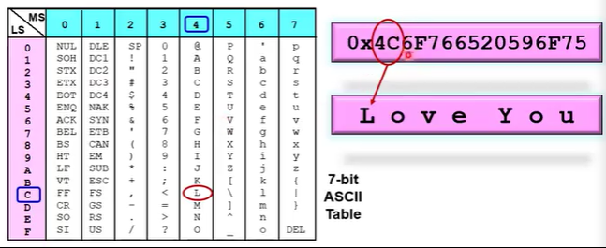

* CR: carriage return | LF: line feed (CR+LF == pressing Enter on keyboard) | SP: space | BEL: makes a noise (will not found in text file)
* Digits are contiguous: 0x30=0, 0x31=1, etc
* Upper to lower is also contiguous: A +32 = a
* Encoding is 7-bits, most significant bit could be used for parity error checking
  + MSB set to either 0 or 1 depending on whether parity encoding is odd or even. If total number of ‘1’s is odd, there is odd parity encoding. If even, then even parity.

## Unicode

* Developed to include more languages e.g. Chinese/Japanese/Korean characters
* 8//16/32-bit character encoding standard that is downward compatible with ASCII

# Boolean Representation

* False = 0, true = non-zero
* Memory storage for Boolean is inefficient as most implementations use a byte (minimum unit of memory) to store the 1-bit Boolean
* 8051 microcontroller supports a small portion of bit-addressable memory to efficiently store Booleans (ON/OFF status)

# Arrays Representation

* A consecutive area in memory storing a series of homogenous data type.

### Is not affected by Big/Little Endian format: the chars still do downward in consecutive order

* Elements are accessed by offsetting the base address (BA) of the array
  + Computation of array element address must take into account data type size
  + [number] x size of data type in bytes = total offset.
  + 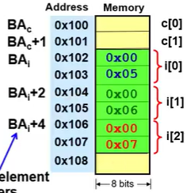
  + 2D array ar[a][b]’s total offset = sizeof(datatype) * ((a*bMAX)+b)

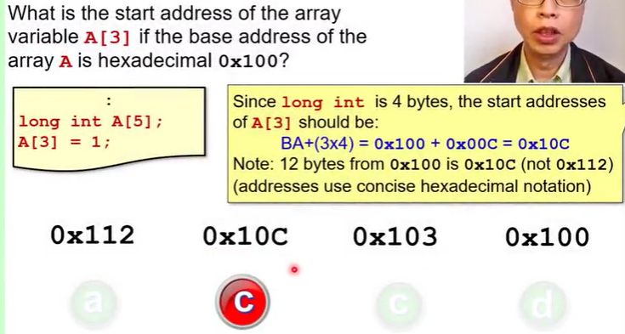

# String Representation

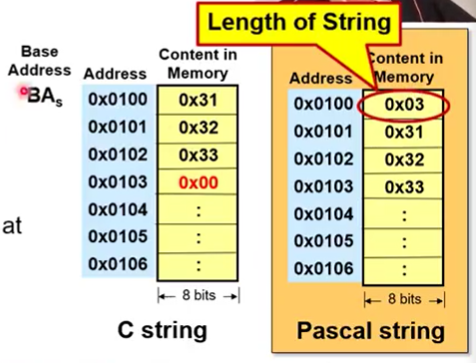

## C-style string

* Array of characters terminated by a null 0x00 character
* The 0x00 character must be at the last address. Note: Little/big Endian only applies to numbers!

## Pascal string

* Has one leading byte (length), followed by length bytes of character data.
* This means that Pascal-style strings can only encode strings of between 0 and 255 characters in length (assuming single-byte character encodings such as ASCII + only one byte is being used to store the string length; max is 0xFF = 255).

# Structures Representation

* No memory allocated until the structure is declared, in which case the struct occupies predefined consecutive locations based on the struct elements’ sizes.

# Pointers Representation

* Value of a pointer is the address, hence its size is fixed regardless of data type.
* Size of pointer depends on computer processor’s address range, i.e. size of CPU address bus / length of CPU address, rounded up to the nearest whole byte (i.e. multiple of 8 if in bits)

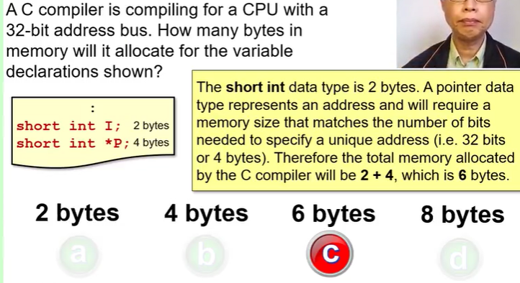

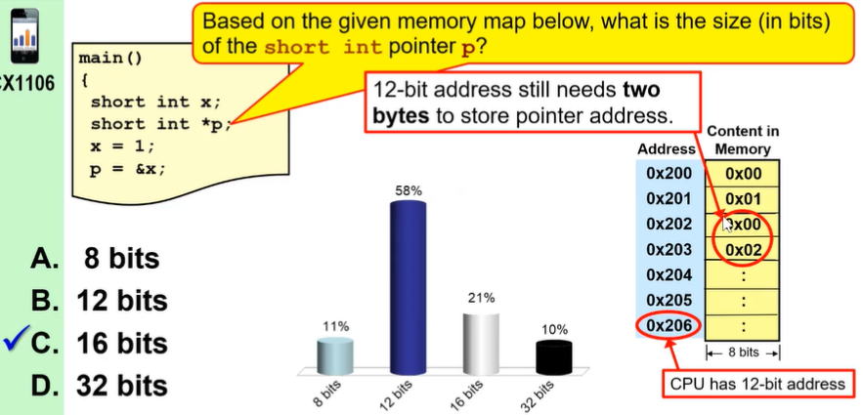

# Data Alignment

* Most computers have restrictions on the allowable addresses for accessing various datatypes
* 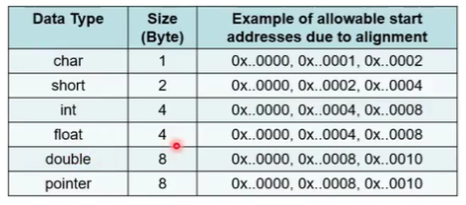

## But why tho

* Main memory has 64-bits (for e.g.), but it consists of multiple individual 8-bit memory modules, which are selected by bank enable signals. (BE0-7)
* Data that is aligned can be read in 1 read cycle (if data bus can take it).
* 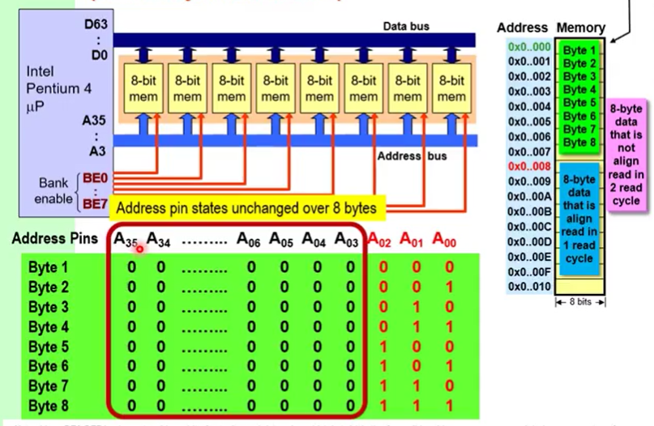
* 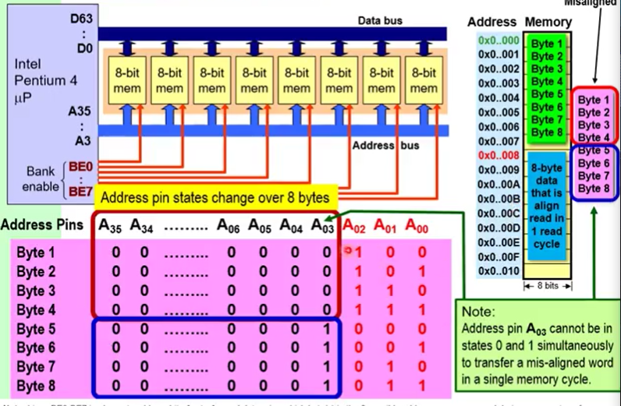
* A00, A01, A02 go in via the bank enable signals, the rest via the address bus.
* So in 1 read cycle A03-A35 can only specify one location.

## Exceptions

* Will not be needed if the processor’s data bus is only 8-bits: multi-byte data will require the same number of read cycles no matter the data alignment.
  + Processor with 16-bit/2-byte data bus only needs to align 2,4, or 8 byte-sized data to even addresses. 1 byte don’t need align.

## Consequences for Structures

* Data padding (addition of meaningless bytes) is used by compilers to ensure alignment of different data types within a structure.
* Applied to each instance of the datatypes in the structure, then to each instance of a structure.
* 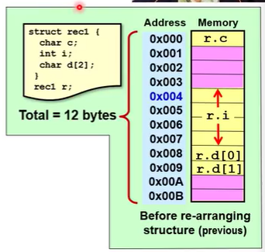
* Rearranged: 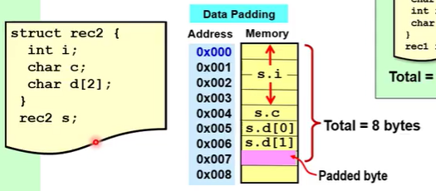(less padding)

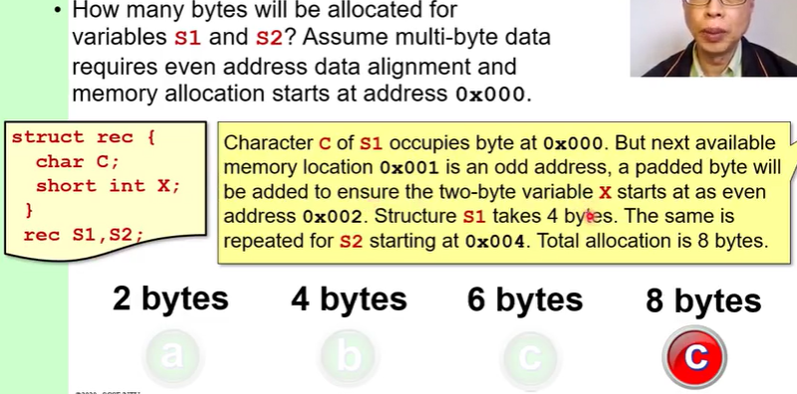

CZ1106 Lecture THREE

INSTRUCTIONS & ARM MODEL

* Memory is partitioned into separate code and data segments.
* Instructions are stored in memory as binary patterns called machine codes. Also represented in more readable mnemonics.

# ARM processor

* Has 16 32-bit registers
* R0-R12 are general purpose registers
* R13 is the **Stack Pointer (SP)**
* R14 is the **Link Register (LR)**
* R15 is the Program Counter (PC)
* **Current Processor Status Register (CPSR)** holds the condition code bits (NZVC)
  + CPSR is NOT a register

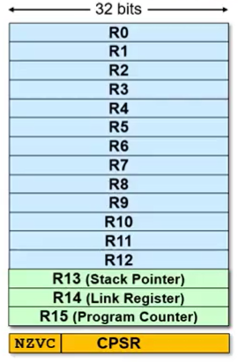

## SP | Stack Pointer (usu R13)

* Maintains a stack in memory to temporarily store register information which is needed later

## LR | Link Register (R14)

* Gets a copy of the PC (R15) when a Branch with Link (BL) instruction is executed
* At all other times, R14 is a general purpose register.

## PC | Program Counter (MUST R15)

* Keeps track of program execution
* Contains the start address of the next instruction to be fetched.
* CPU automatically increments the addres by the length of the instruction executed, i.e. by 4 bytes in the ARM 32-bit CPU
  + Sequential execution can be altered by modifying the contents of the PC to a new address location
* Due to pipeline architecture of ARM CPU, value in PC is the address of the current instruction being executed plus 8 bytes (i.e. 2 instructions)

### Always increments, even if there is no next instruction

## CPSR Condition Code Flags

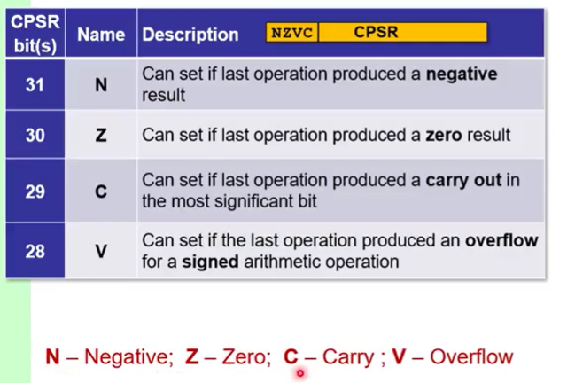

# ARM Instruction Format

* One instruction takes up 32/64 bits depending on whether the CPU itself is 32/64
* Most instructions consist of two parts:

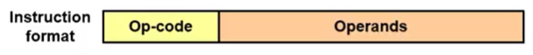

* op-code specifies operation to be carried out
* remaining bits (operands) specify the data itself/the location of data/results storage
* Some operations produce no storage result but alter program sequences/influence status flags
  + e.g. N, Z, V, C

## INSTRUCTION | Role

* Make purposeful changes to the current state of the processor
* Visible current state of a processor is defined by the programmer’s model and contents in memory**
* Types of instructions:

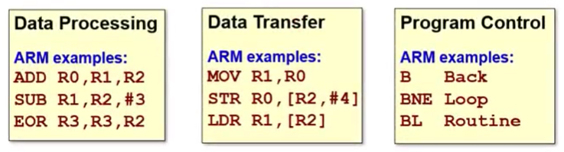

## **Programmer’s Model & Memory

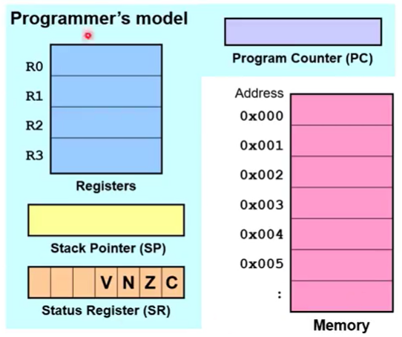

## OPCODE | Encoding (in instruction)

* In binary
* If there are 80 different operations, need at least 7 bits of opcode to represent all unique bit patterns
* More variety of instructions = longer the length of each instruction as more bits are needed to uniquely represent the instruction

# **MOV ,**



* Two-operand instruction that copies the source operand (R0) to the destination (R1) operand.
* Operands are register directs
* Makes one memory access (instruction)

### CANNOT access the CPSR

## MOVS

* Tests if the right side operand is negative (N) or zero (Z). If yes, the corresponding CSPR status bit (1st for negative, 2nd for zero in NZCV) will change to 1.
  + Will not change the CSPR if the NZCV has already been set “correctly” from a previous operation, e.g. it is already 1000 and you MOVS R1, #0xFFFFFFFF

MOV PC, R1 ;make a jump to address in R1

MOVS R0, R0 ;test for N or Z condition in R0.

# **LDR , []**

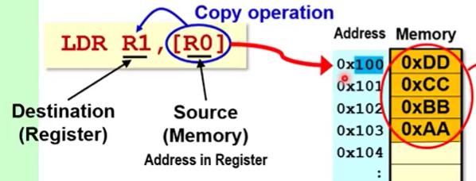

R0 is equal the 8-bit 0x0000 0100

* Copies 4-bytes of memory content to a register
* Right source operand must be a [register indirect] that contains the starting address of the thing you want to copy.
  + Illegal: LDR R1, R0. R0 is a register direct.
* Makes two memory accesses (instruction + [R0] data)
* Data alignment constraint applies: 4-byte data read/written to memory must start at an address which is a multiple of 4.
  + Effects of an unaligned memory access depends on ARM architecture but will result in performance degradation

# Role of Processor

* IR | Instruction Register
* BR | Buffer Register
* CU | Control Unit
* PC | Program Counter
* Data transfer on external bus between CPU and memory is slower than within CPU’s internal bus (von Neumann bottleneck)
  + Keep regularly used operands in CPU registers
  + Or use Harvard architecture: keeping instructions and data in separate memories make instructions execute in more regular cycles via parallel fetches.

# 1. Fetch (instructions)

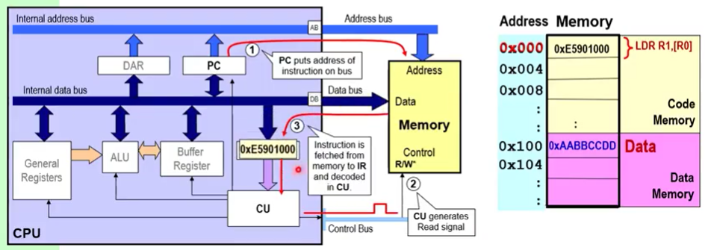

* 1. PC puts the address (e.g. 0x000)
  2. CU tells memory to send the information via the data bus and into the IR
     1. “data bus” is a generic name for anything retrieved from memory, is not necessarily data

# 2. Decode

2.1 CU decodes the instruction.

# 2.5. Need to fetch data?

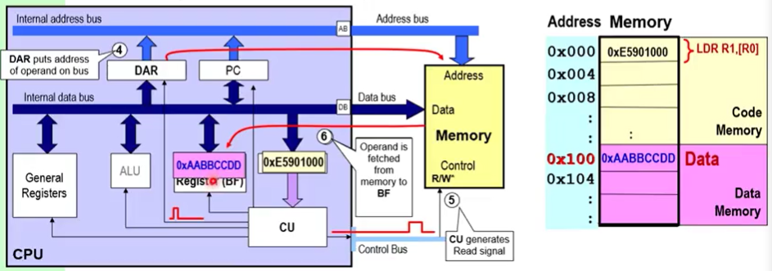

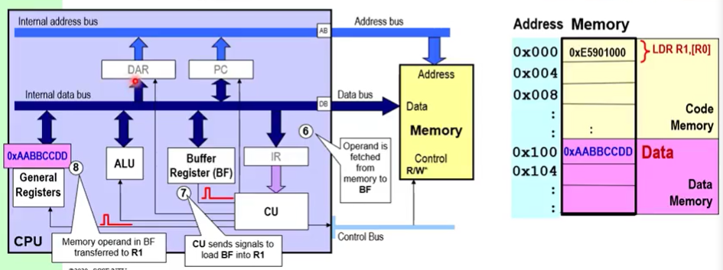

2.5.1 If more data is needed, repeat step 1 but instead of PC, it’s the DAR storing the address + info goes into BF instead of IR.

2.5.1.1 Note: BF is not in the programmer’s model

2.5.2 Info in BF goes into R1.

# 3. Execute

CZ1106 Lecture FOUR

ADDRESSING MODES

* Concerned with how data is accessed (not processed)

# Assembly Program

* Mnemoics; each has a one-to-one correspondence with a binary pattern
* Are hardware-dependent and address the architecture of procesor directly (are CPU register-aware and reference them by name
* Converted to machine code by an assembler.

## Why Assembly?

* Codes with faster execution speed
* More compact program size (for small memory capacity)
* Exploit optimised features of processor’s ISA

## When Assembly?

* Critical part of the OS software, esp parts of kernel constantly being executed
* Input/output intensive codes, e.g. device drivers
* Time-critical codes

# Addressing Modes for OPERANDS

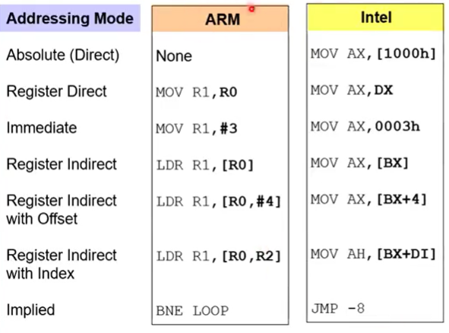

# Register Direct

* Operand is the content of the specified register
* Can be used for both destination and source operand
* Fast addressing mode since no further memory access is involved during execution
* All ARM’s 16 registers can be a register direct operand

e.g. MOV R1, R0

# Immediate Addressing

* Value of operand is directly specified within the instruction itself
* Immediate value signalled by #; 32-bit value of the immediate value is passed e.g. 0x0000 0003
* Can only use immediate addressing as source operands (i.e. copy values into registers, not other way)
* Used for loading constant values into registers. Values must be known at the time of coding.

## Only 12 of the 32-bit ARM instruction set is given to the immediate operand. So how can a 12-bit operand encode all 32-bit immediate values??

* It cannot; it can only describe a subset of all 2^32 possible values.
* 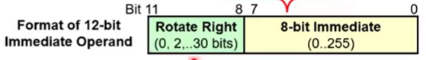
* Immediate value is an 8 bit number (1-byte i.e. a pair of hex values, or 0 to 255) rotated right by 2n bits, where n is given by 4 bits (a single hex value, or 0 to 15)
* 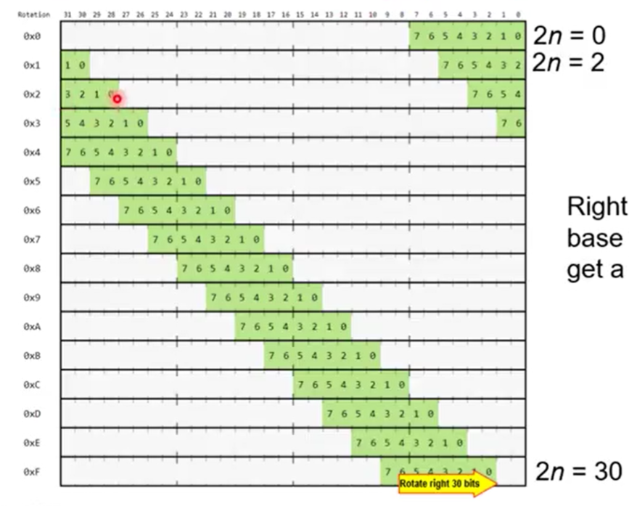

## Ranges

* values within 8 bits (255/0xFF) are always valid (don’t even need a right rotate value)
* for values more than 8 bits (>255):
  + Write out the immediate value you want in binary.
  + Encapsulate all the ‘1’s in a single 8-bit number.
  + Check that this 8-bit number is 2n spaces away from the LSB.
    - If it is, it is valid.
    - If it is not, you cannot use that immediate value, e.g. 0xFFF. Solution: use MVN 0x000, MOV 0xFFC then +3, or other roundabout ways

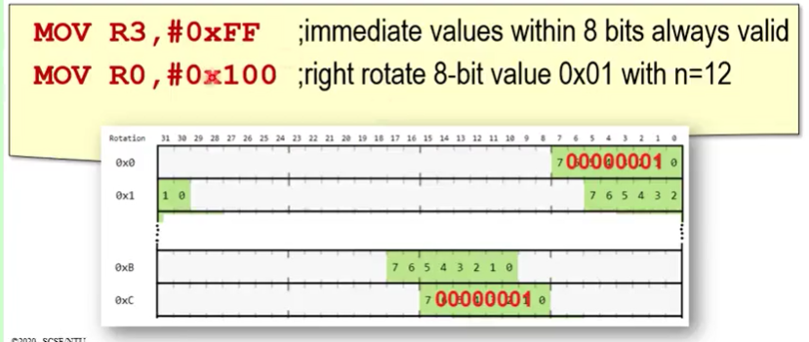

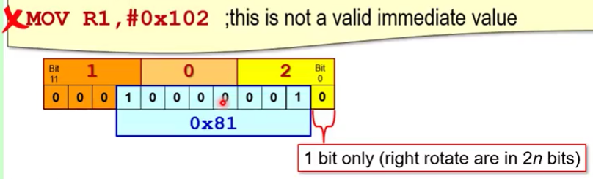

* Note: Assembler actually does all these necessary calculations already and gives warning if requested immediate value cannot be encoded.

## Well shit, what now?

* A combination of instructions can be used to achieve the desired immediate value that is not valid.
  + MOV R1, #0x100
  + ADD R1, R1, #2 ;we achieve 0x102!

The above two (register direct/immediate addressing) do not allow CPU to access operands stored in memory.

How to specify 32-bit address in memory using 32-bit register??

* ARM can specify the 32-bit address of the operand in a 32-bit register.
* Register with the memory address points to the memory location where the operand is stored
* Memory operand is fetched during instruction execution using register indirect addressing.
* ARM uses LDR and STR mnemonics for this. LDR = copies memory content to a register. How about the other way around, register content to memory??

# Register Indirect with Offset

* Adds a specific offset value to the indirect register (base plus offset) to compute the effective address (EA) in memory.
* Does not change indirect register’s content.
* 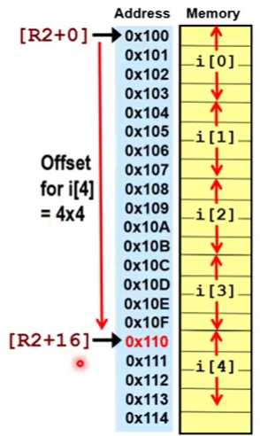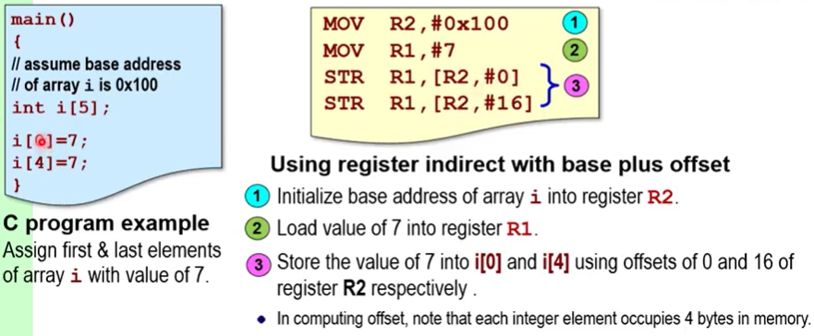
* 

e.g. LDR R1, [R0, #4] ;thing located in the (memory address in R0, plus 4) is copied into R1.

# Register Indirect with Index Register

* Like offset but instead of immediate value its another index register lol
* This index register is modifiable during runtime.
* Does not change indirect register’s content.
* 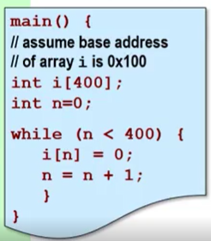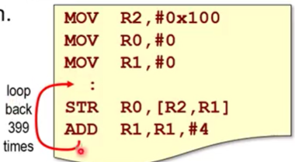
* STR: 2 memory cycles, ADD: 1 memory cycle. Altogether the loop takes 3x400 = 1200 cycles.

e.g. LDR R1, [R0, R2] ;allows different array elements to be retrieved wrt base address

# Register Indirect with Autoindexing

* Offset value is added to the autoindex register (AR) to compute effective address (EA) and AR gets modified.
* Telltale: “!” or three operands. Causes autoindex register to be modified w/EA
* CHANGES indirect register’s content.
* 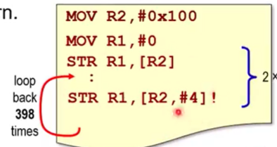
* STR: still 2 memory cycles but now altogether loop only takes 2x400 = 800 cycles!
* Offset value can either be #immediate value or an index register

**Unchanged: [destRstr, #val]**

**Pre-index: [destRstr, #val]!**

**Post-index: [destRstr], #val**

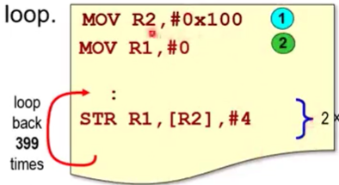

# The System Stack

## Stack: first-in, last-out. Pop = remove from stack. Push = add to stack.

* System stack in ARM is maintained by the dedicated stack pointer (SP; R13).
* Note: “higher memory” means going down the address visually; vice versa for “lower memory”

|  |  |
| --- | --- |
| Full Ascending - Point to an item on the stack  - Grows towards higher memory | Empty Ascending - Point to empty space  - Grows towards higher memory |
| >> Full Descending - Point to an item on the stack  - Grows towards lower memory* | Empty Descending - Point to empty space  - Grows towards lower memory* |

*from 4-byte element to 4-byte element; within each element the 4 bytes will still fill in increasing memory (i.e. step up 4 times, then step down once, once, once, once then repeat.

Note the 4x1 stepping down does not affect the original index location.)

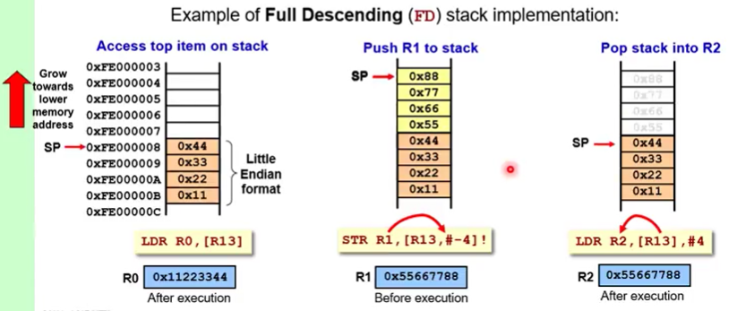

## Empty Ascending

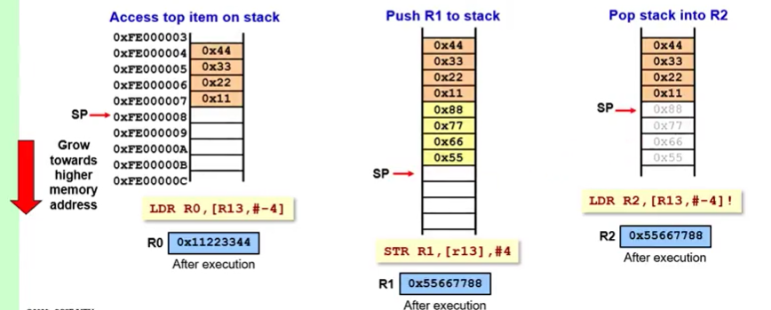

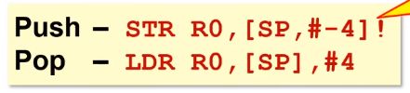

Sidenote: don’t need to clear the element from the registers. The stack is solely determined by the stack pointer. Push: just write in and override. Pop: just move the stack pointer back.

# PC-Related Addressing Modes

* New address can be loaded into the program counter (PC, R15) to alter the sequential order of program execution.
* Note: in ARM processor the PC points 8 bytes ahead of the current executed instruction due to pipeline architecture

## Absolute Jump

* Uses the absolutely desired memory address, either as #immediate value or [register indirect]
* Not position-independent
* MOV PC, #0x060 ;jump to the code at address 0x060

## Relative Jump

* Uses a branch instruction (e.g. B) with an appropriate signed offset.
* Is position-independent.
* B codeB ;jump to codeB

# Position-independence

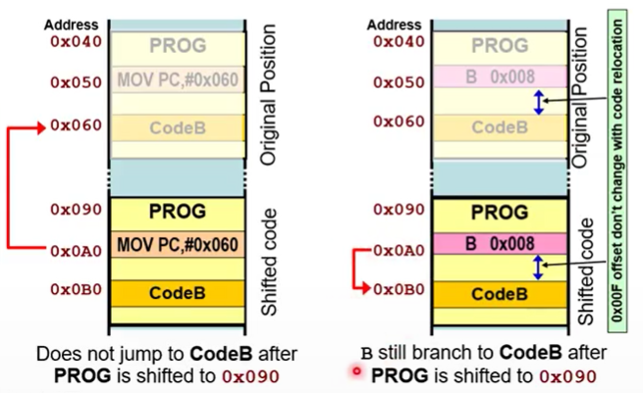

## How to achieve?

## 1. Use PC-relative addressing, since the whole chunk of data+instructions will move together. **PC-relative offset: desired address – PC value – 8**

1.1 -8 because the PC points 8 bytes ahead of the current executed instruction. Therefore 8 has to

be minused off the PC-relative offset calculated, because that 8 “already exists” in the PC.

## 2. Use ADD R0, **PC**, #0xpc_relative_offset.

## Or: use ARM branch instruction B.

## Note: once one register achieves position independence, you can use that register to write all subsequent position independent codes.

## Note: WHEN DEALING WITH THE PC, THE LITERAL VALUE IS USED, NO +-8 IS NEEDED.

e.g. if you want to go to 0x018, doing MOV PC, #0x018 will suffice. No +-8 bytes is involved – that is only what the PC does if left on its own.

Sidenote: Why create an infinite loop? Because the ARM processor doesn’t actually know where to stop. Having an infinite loop instruction prevents the processor from executing instructions that don’t belong in your program.

## Note: changing any register other than the PC is always position independent

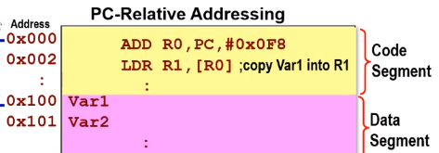0x100 – 8 = 0x0F8

Lecture Examples:

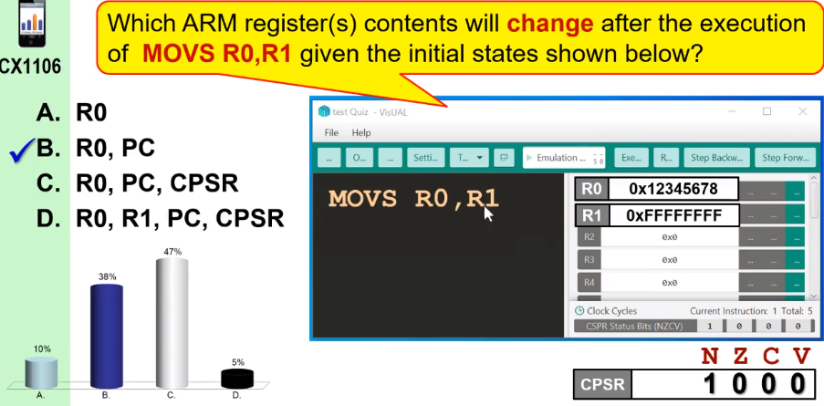

* NZCV flags will not change if already set (idempotent)
* PC will always move forward even if evaluating the last instruction in the program.

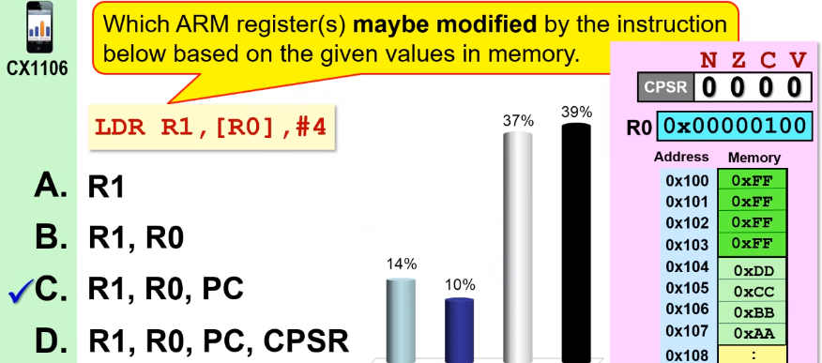

* LDRS doesn’t exist. To test value moved, must use LDR then MOVS R1,R1 to set NZVC.

CZ1106 Lecture FIVE

INSTRUCTION SET

# Data Transfer

## Moves data between registers and memory

# **MOV destRstr, src**

* MOVS: set N or Z flag
* **MVN**: source operand is bit-wise inverted before moving into destination register

### Two clock cycles:

# **LDR destRstr, [srcRstr] (,offset)**

* LDR**B**: copy 8-bit/1-byte/0x__ pointed by [src] into destination register. This value is zero-extended to 32-bits.
  + Does *NOT have data alignment issue* (exception to LDR’s 4-byte alignment rule)

# **STR srcRstr, [destRstr] (,offset)**

* Copies 4-bytes of register content to a memory address (register indirect)
* Data alignment constraint applies: 4-byte data read/written to memory must start at an address which is a multiple of 4.
  + Effects of an unaligned memory access depends on ARM architecture but will result in performance degradation
* STR**B**: copy 1-byte (same thing: *no data alignment*, exception to STR’s 4-byte alignment rule)

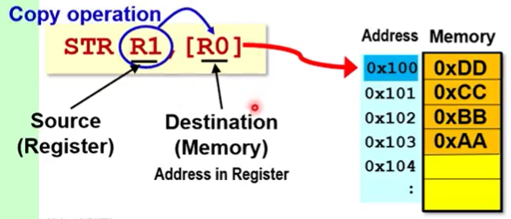

R0 contains the 8-bit 0x0000 0100

**(,offset)**

**Unchanged: [destRstr, #val]**

**Pre-index: [destRstr, #val]!**

**Post-index: [destRstr], #val**

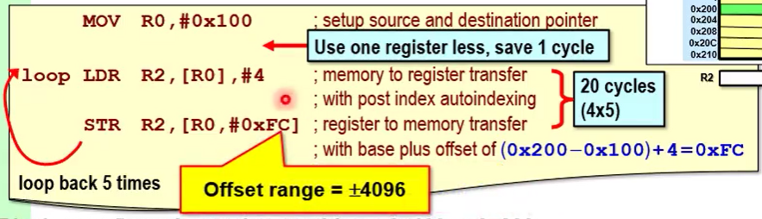

0x200 = 0001 0000 0100

0x104 = 0010 0000 0000

Diff = 0000 1111 1100 = 0000 15 12 = 0FC

# Data Processing

## Modifies data in registers through arithmetic or logical operations

arithmetic:

# **ADD destRstr, Rstr, Rstr/#**

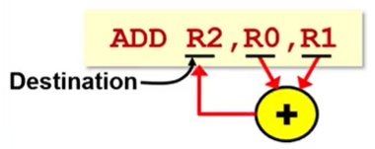

* Destination and middle operands must be registers (and can be the same register) but rightmost operand can be a register or immediate value.
* R0 and R1 undergoes “naive hexadecimal adding”, i.e. just add only.
* Data alignment constraint applies: 4-byte data read/written to memory must start at an address which is a multiple of 4.
  + Effects of an unaligned memory access depends on ARM architecture but will result in performance degradation
* ADD**S**: set N, Z, V and/or C flags
  + C: overflow when adding unsigned numbers (carry at MSB)
  + V: overflow when adding signed numbers, i.e. both signed numbers have the same sign but the result has the opposite sign.
  + 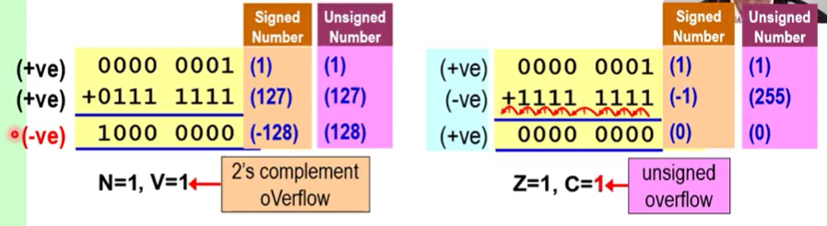

# **SUB destRstr, Rstr, Rstr/#**

* Minuend - subtrahend
* *Subtrahend is converted into the 2’s complement, then minuend and subtrahend are added*.
  + 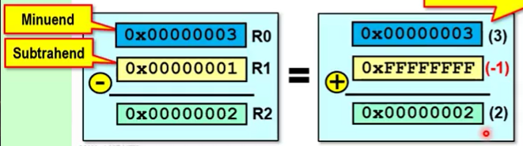
* SUB**S**: set N, Z, V and/or C flags
  + C=0 if the subtraction produces a borrow (unsigned value of minuend < unsigned value of subtrahend) i.e. unsigned underflow and C=1 when u.v.o. minuend >= u.v.o. subtrahend
  + V=1 when the result is out of the signed 32-bit range (-2^31 to 2^31)
* **RSB(S)**: reverse the subtraction order (swap minuend and subtrahend). Used when left number (minuend) needs to be a constant number
* Example:
  + 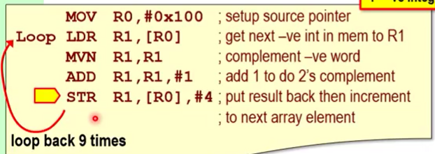
  + 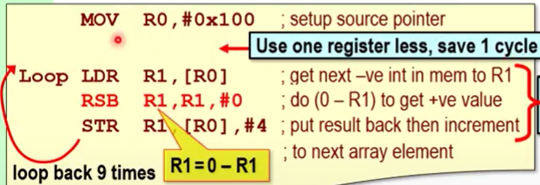

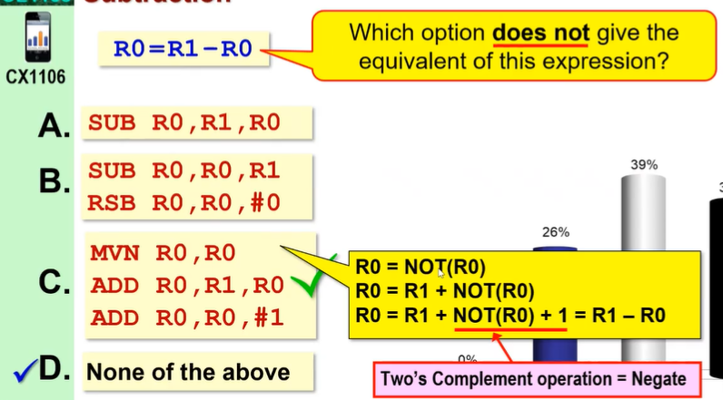

## Carry-based Arithmetic Instructions

* Takes the carry bit into consideration, to support multi-precision arithmetic involving data larger than the 32-bit registers in the ARM CPU.

ADD with carry -> **ADC**

SUB with carry -> **SBC**

RSB with carry -> **RSC**

logical:

* Provide various Boolean operators.
* E.g. MVN is a two-operand instruction that does the NOT operation.
* “S” suffix can be used to influence the N/Z bits in the CSPR flags

# **ADD destRstr, Rstr1, #/Rstr**

* Can be used to clear specific bits in Rstr1 by using binary 0 mask
* 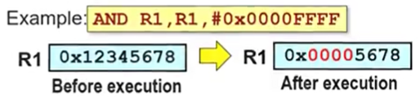

# **ORR destRstr, Rstr1, #/Rstr**

* Can be used to set specific bits in Rstr1 by using binary 1 mask

# **EOR destRstr, Rstr1, #/Rstr**

* Can be used to invert specific bits in Rstr1 by using binary 1 mask
* 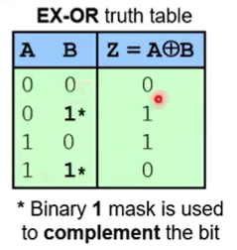

Non-influencing bits are called the pass.

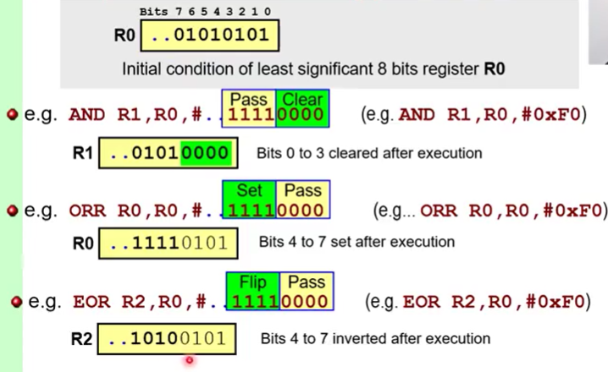

Example:

0 state = “ground” = make the LED turn on.

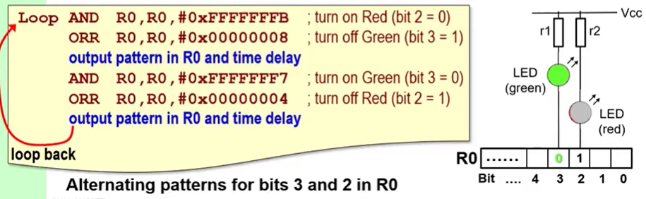

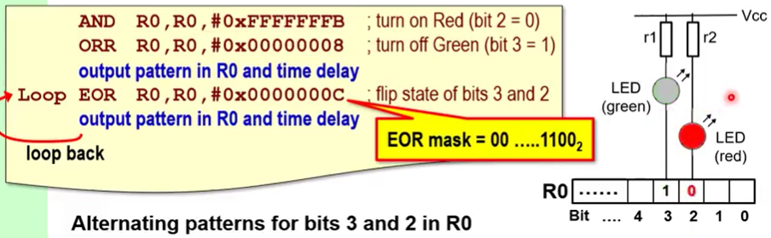

shift and rotate:

### Shifting left multiplies the number by 2^n, n = number of bits shifted. Divides for right.

* + Shifting is BITWISE, hence a shift of #4 is 4 bits which is only one hexadecimal movement!
    - Hence, convert the hex into binary first, then do the conversion.
* “S” suffix used to influence the C flag.
* Can be used with data transfer/processing instructions. The shift/rotate will be applied to the rightmost operand:
  + 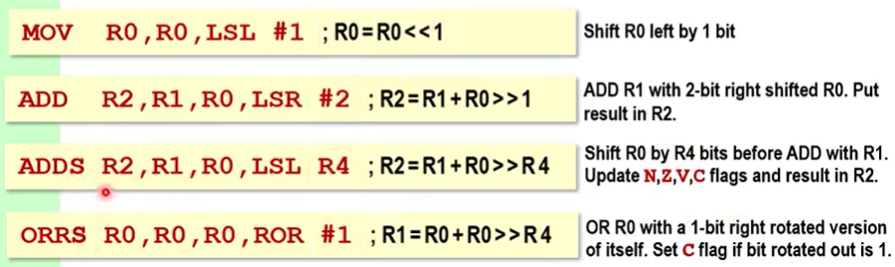
  + This process is very efficient in ARM. Why? Because its architecture accomodates a barrel shifter right before the 32-bit ALU which is built in for all instructions no matter if it is actually used or not.
  + 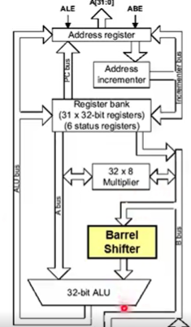

# **LSL Rstr/#**

* signed/unsigned multiply: binary 0 shifted into LSB
* 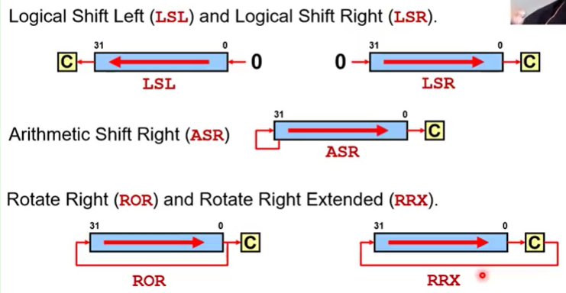

# **LSR Rstr/#**

* unsigned divide: binary 0 shifted into MSB
* 

# **ASR Rstr/#**

* signed divide: sign bit shifted into MSB
* 

# **ROR Rstr/#**

* the LSB shifted out is returned in as the MSB and is also duplicated into the C-flag.
* 

# **RRX Rstr/#**

* the LSB shifted out is put into the C-flag, the C-flag bit comes in as the MSB.
* 
* Can only do 1 bit.

Example:e

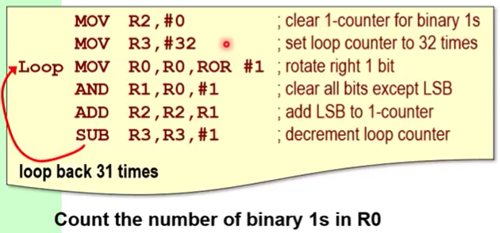

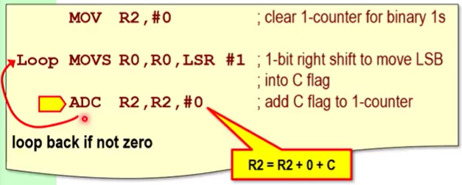

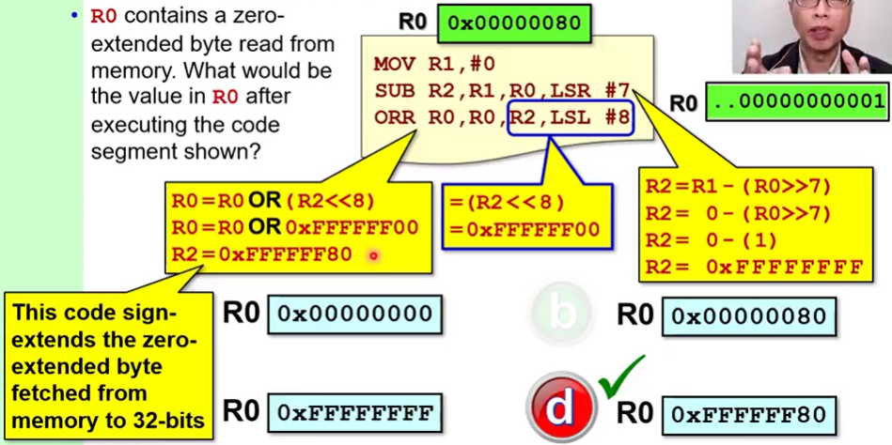

# Program Control

## Alters the normal sequential execution flow of a program.

## Implemented by modifying the contents of the Program Counter (left) or by using relative jump and the branch “B” command.

* 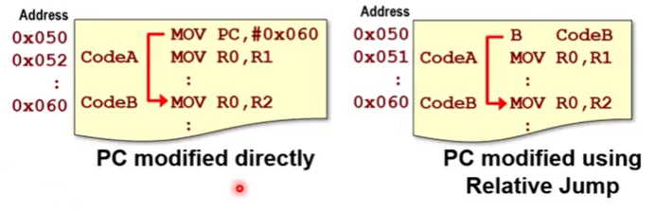

A jump can be executed based on a given condition and this is called a conditional branch.

* if, if-else, for/while loops

# **Bcc**

* If the Bcc is satisfied, the program will jump to the desired code block. Once it is not, program will continue execution.

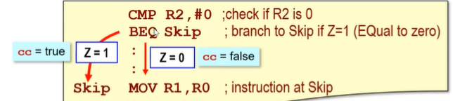

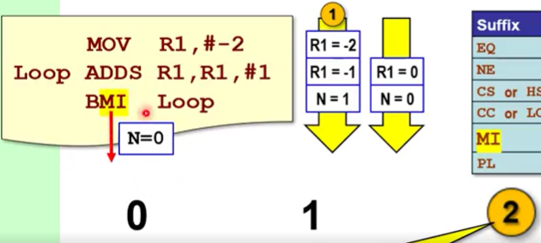

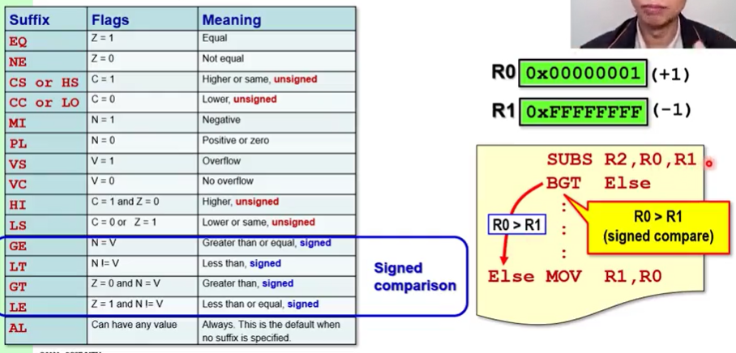

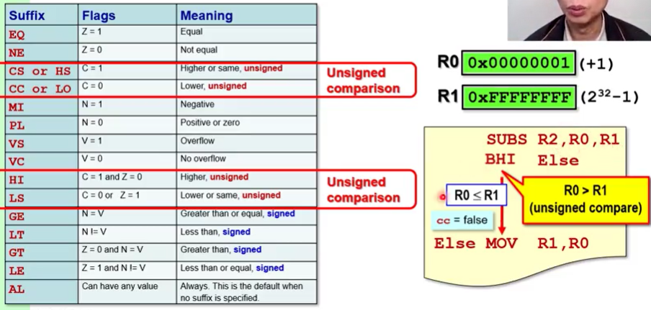

### Instruction prior to Bcc must influence the NZVC flags i.e. have an S at the end.

* This is because all Bccs only check the NZVC flags. Therefore the instructions before the NZVC must influence the flags for the Bcc to test.
* If cc is true, displacement is added to the PC, otherwise next instruction is executed.
  + Uses PC-relative addressing mode with displacement range of +-32MB
  + PC value used to compute required displacement is 8 bytes ahead of the current Bcc being executed.
  + Bcc is used with address labels to allow assembler to compute required displacement values.
* CMP (to an immediate value) & BEQ

### ARM CPU does not know if something is a signed or unsigned value.

* N = 1 doesn’t mean it is unsigned value.1

# Looping

## Loop if flag is true

MOV R3, #32 ;set loop counter to 32

SUBS R3, R3, #1 ;decrement loop counter

BNE Loop ;execute “Loop” and only stop looping when flag is false, i.e. Z=1, i.e. R3 = 0

Alternatively, can use #31 instead of #32 and then use BPL instead of BNE. BPL will only continue when N=1 (i.e. R3 = -1). Same thing.

# Conditionals

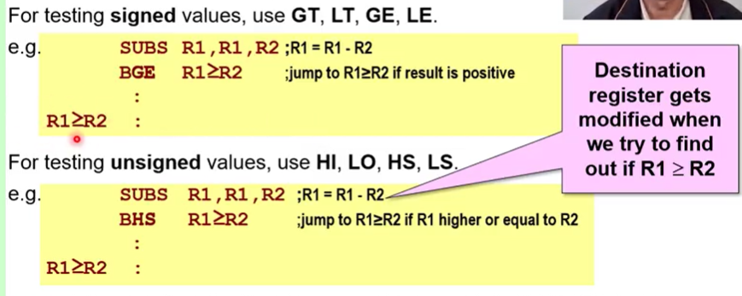

## How to not modify original destination?

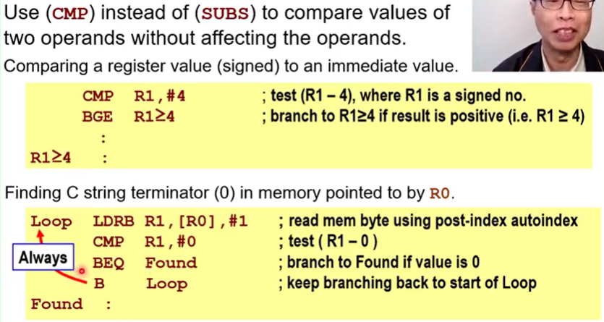

# **CMP destRstr, srcRstr**

* Subtracts the source operand from the destination register and sets the CC flags according to the results.
* Destination register unmodified after CMP.

# **SUBS (recall)**

other conditional test instructions:

do not modify the destination operand

do not need the “s” suffix to influence the condition code flags (N, Z, V, C)

# **CMN R0, R1**

* Compare negative
* Set NZVC based on R0 + R1

# **TST R0, R1**

* Test bits
* Set NZVC based on R0 AND R1

# **TEQ R0, R1**

* Test equivalence
* Set NZC based on R0 EOR R1.

The C flag for TST and TEQ can be influenced by applying shift and rotate.

Example – **Find Largest Number**

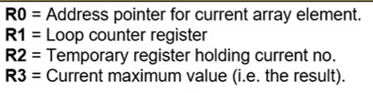

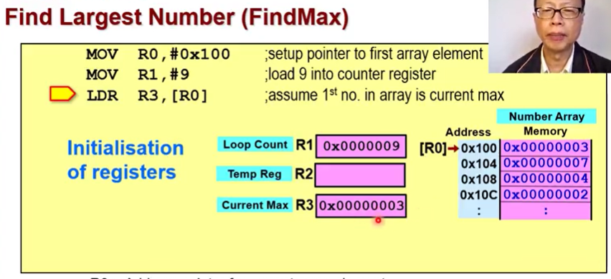

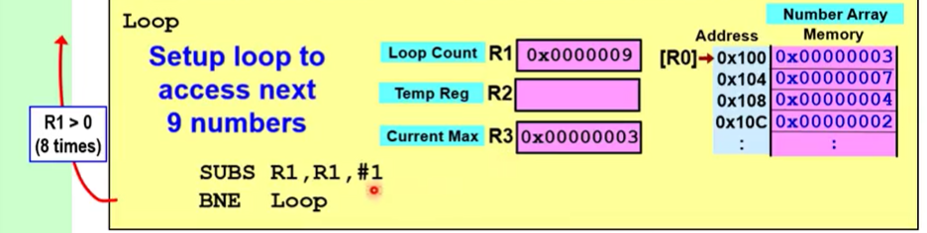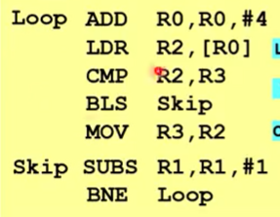

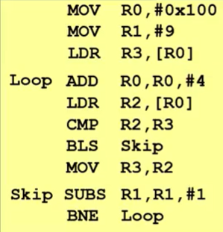

### Optimisation 1: pre-index autoindex to next element. Saves 9 cycles.

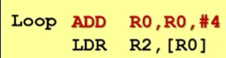--> 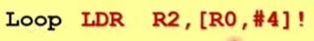

### Optimisation 2: BLS SKIP --> conditional execution

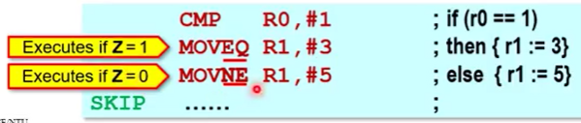

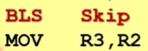-->

Example – **Loop an array of 8 numbers, then do an average to obtain quotient and remainder.**

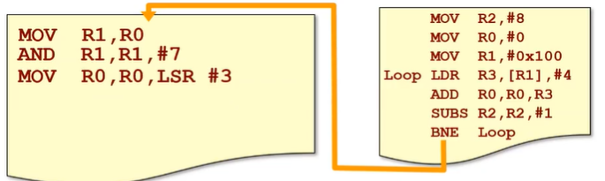

### Set up a looping construct:

MOV R1, #loopcounter

loop xxxxxx

yyyyyy

SUBS R1, R1, #1

BNE loop

### Access consecutive array elements in memory:

LDR store, [array], #shift?

### Shift performs divide and multiply:

MOV R0, R0 LSR #3 == divide by 2^3

### Masking

Optimisation 1: initialise cumulative register R0 with first array element instead of zero.

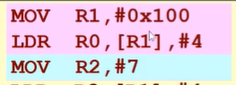

Optimisation 2: use R0 as source register when doing the AND operation

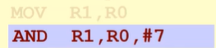

CZ1106 Chapter SIX

/// MODULAR PROGRAMMING ///

## Each instruction is exactly 4-bytes.

Software decomposed into several less complex modules. Modules can be designed and tested independently.

Modules can reduce overall program size through re-using modules (DRY).

Good modular programming:

+ Loose coupling – data within module is entirely independent of other modules (local variables).

+ Strong modularity – should perform a single logically coherent task.

# Subroutines

* Modules are implemented as subroutines that can be called as a callee by a caller.

# **BL subName**

* Used to make subroutine call
* Return address (i.e. the address of the next instruction after the branch, or just the current PC value under the 8-ahead system) is stored in the link register (LR; R14), then the subroutine address is stored to the PC. I.e. affects PC and LR.
* Equivalent to writing:
  + MOV LR, PC ;because PC is pointing 8 bytes ahead, which is just nice already after the B

subName instruction

* + B subName
  + ^but this requries two clock cycles instead of one
* 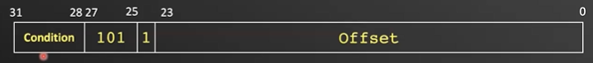

# **BX LR**

* LR contains the return address, instruction copies value over to PC.
* NOTE: VisUAL does not support BX LR!! workaround: use **MOV PC, LR**

Note: Why use BL and BX instead of B?

B overwrites value in PC: old PC value in main program is LOST. Need to add another branch at the end of the subroutine, but then need to know the exact memory location during compilation. Not an effective approach.

# Steps to write subroutines:

1. Write subroutine name
2. Write **MOV PC, LR** at the end ;same as BX LR.
3. Need register(s) to count variable(s) that the subroutine will modify? Initialise:
   1. **MOV R0, #0**
4. Need loop counter?
   1. If so, initialise:
      1. **MOV R2, #loopCounter**
   2. Write loop name
   3. Close the loop:
      1. **SUBS R2, R2, #1**
      2. **BNE loop**
5. Don’t need loop counter, but need a “while” loop?
   1. If so, put the exit condition at the top of the loop. E.g:
      1. **CMP R1, #0 ;check if R1 is 0**
      2. **BEQ done**

Three ways to pass parameters: registers, memory block, system stack. Depending on passing method, may need to remove parameters.

# 01 | Parameter Passing using REGISTERS

* Parameters placed into register before calling subroutine. Can be passed by value or by reference
* Pro: Efficient as parameters are already in register and can be used immediately.
* Con: Number of parameters passed limited to the available registers. Useful when number of parameters is small, **4 or less.**
* Not all R0-R12 are preferred to pass parameters. Best practices: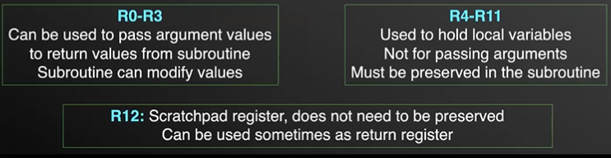

If need to use R4-R11 in subroutine, try to store those values in the stack then put back.

Example: bit counting subroutine

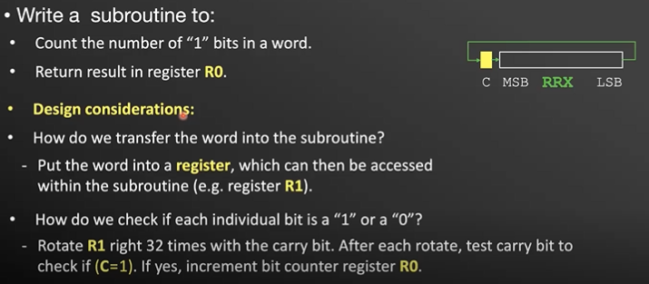

How to read bitwise? Rotate right with the carry bit and test carry bit after each rotate to check if 1 or 0.

Solution 1:

## Issue: carry of SUBS will be used in RRXS --> R1 value will be destroyed.

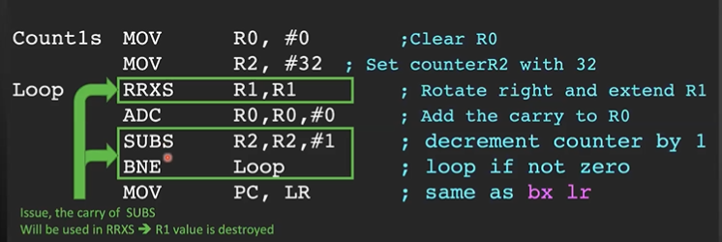

Solution 2:

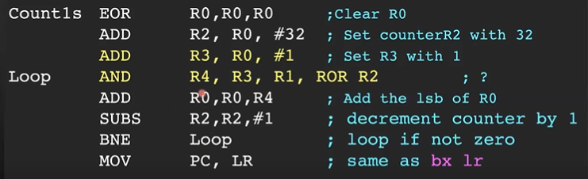

## AND R4, R3, R1, ROR R2

1. Take R1 and rotate right by R2

2. AND R3 (00...001) with R1.

3. Put the result in R4.

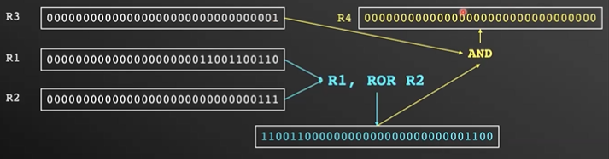

# 02 | Parameter Passing using MEMORY

* Region in memory is treated like a mailbox and used by both calling porgram and subroutine.
* Parameters to be passed are gathered into a block at a predefined memory location.
* Pro: can pass a large number of parameters.
* 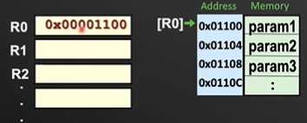

Example: lower to upper case in ASCII subroutine

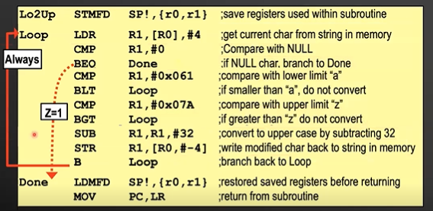

Note: the above assumes each character is 32 bits. What if they are stored in 8 bits only? (1byte, 0xFF)

Solution: use LDRB and STRB.

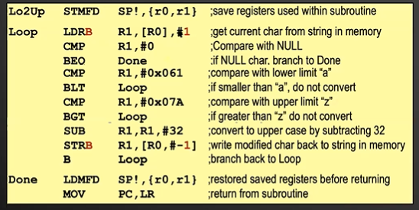

# 03 | Parameter Passing using STACKS

* Stack: first-in, last-out
* System stack is maintained by a dedicated stack pointer (SP, R13)
* FULL DESCENDING:
  + Stack is preferred to grow from higher to lower memory address i.e. starts from the max address (visually, starts out at the “bottom” of the graph).
  + Stack pointer points to the top item on the system stack
* Parameters pushed to the stack must be removed by the calling program IMMEDIATELY AFTER returning from subroutine. If not, repeated pushing of parameters will lead to stack overflow.

# Push Data to Stack:

# **STR srcRstr, [SP, #-4]!**

**STMFD SP!, {R0, R1} or {R0-R1}**

* STM = stores multiple data into the stack
* FD = full descending
* ! = update the SP after operation
* Registers are read by descending order, i.e. from highest memory address then fill lower (upward visually).
* Regardless of how the registers are read, the highest index register (R3) will always store at the highest memory address and fill to lower indexes/memory addresses (then R2, then R1...).
* 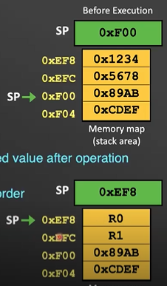

# Pop Data off Stack:

# **LDR R0, [SP], #4**

# **LDMFD SP!, {R0, R1} or {R0-R1}**

* Here, registers are read by descending order, i.e. from lowest memory address then fill higher (downward visually).
* Regardless of how the registers are read, the lowest index register (R3) will always store the data of the lowest memory address and fill to higher indexes/memory addresses (then R2, then R1...).
* Note: after popping, the data is not erased from memory – it still exists there. Only the SP changed to omit it.
* Note: if don’t need to pop (retrieve) the data, can just do ADD SP, SP, #4N.

Example: sum from 1 to N

Sum the positive numbers from 1 to N, N = value passed to the subroutine

Computed sum updated to memory variable Answer at address 0x100

All parameters passed via stack.

## Step 1: Put parameters in register, then use STMFD

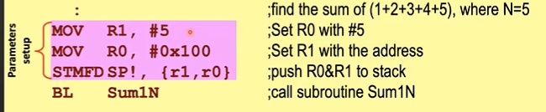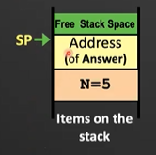

## Step 2: Call the subroutine, then remove the parameters via LDMFD or ADD SP.

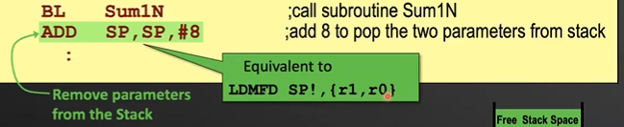

## Step 3: Write the subroutine.

## STMFD SP!, {Rx-Ry} ;define your own “variables” for the function

## LDR Rx, [SP, #4N] ;retrieve the data from the stack into your own variables

## loop .... ;do your thing in the function using the registers

## ; write the answer into the appropriate address (normally the answer will be passed by reference to the stack so STR urAns, [ans] will do

## LDMFD SP!, {Rx-Ry} ;destroy the variables you created for the function

## MOV PC, LR ;exit 0

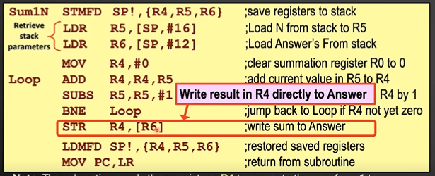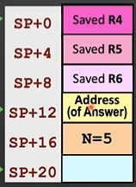

^Transparent Subroutine: will not affect any CPU resources used by the program calling it. All local registers used by the subroutine (R4-R11) must be saved on the stack on entry and restored from the stack before returning.

# Passing by value and by reference

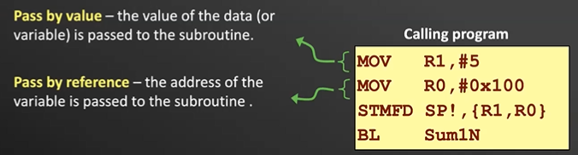

Pass by reference: parameter passed is to be modified by the subroutine, or large quantity of data (e.g. array) is being passed between subroutine and calling program.

# Local Variables

* Subroutines often use local variables whose scope and lifespan exists only during the execution of the subroutine.
* Memory storage for local variables is created on entry into subroutine and released on exit from subroutine.
* System stack is the ideal place to create memory space for temporary variables. This temporary memory space is called the stack frame.

# Accessing stack frame via Frame Pointer

Stack frame can be accessed with a frame pointer (FP, usually R11) or the stack pointer (SP)

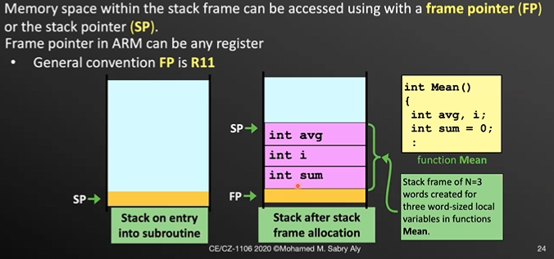

1. Original contents of R11 is saved on the stack before it is used as the frame pointer
2. FP now points to the saved R11 and a stack frame is created by adding frame size 4N to SP.
3. R11 is the frame reference and appropriate negative displacement from R11 can be used to access any stack frame variable.

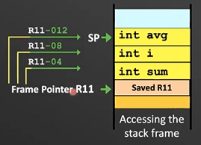

1. When exiting the subroutine, the stack frame can be destroyed by adding 4N+4 to SP and copying the saved R11 value on the stack back into R11.
   1. ADD SP, SP, #4N+4
   2. LDR R11, [R11]

# Accessing stack frame via Stack Pointer

1. Stack frame is created by adding frame size 4N to SP.
2. SP is the frame reference and appropriate positive displacement from SP can be used to access any stack frame variable.

* Pro: more efficient, don’t need to setup frame pointer
* Con: more restrictive as system stack cannot be used within subroutine without changing reference SP.

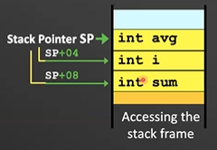

# Problem with Nested Subroutines

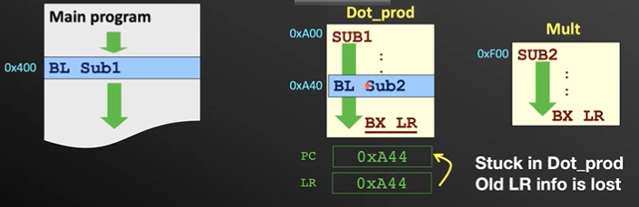

1. Main program -> subroutine 1
   1. PC: goes from 0x408 to 0xA00
   2. LR: becomes 0x400+4 = 0x404
2. Subroutine 1 -> subroutine 2
   1. PC: goes from 0xA48 to 0xF00
   2. LR: goes from 0x404 to 0xA44.
3. Subroutine 2 finishes.
   1. MOV PC, LR
   2. PC: goes from 0xF00 to 0xA44.
   3. LR: remains as 0xA44.
4. Subroutine 1 finishes.
   1. PC: loops back to 0xA44.

Problem: old LR is lost! LR needs to be saved somewhere safe --> system stack! When to save it?

* Just before any BL instruction
* At the beginning of each subroutine

Example: dot product



Multiplication subroutine:

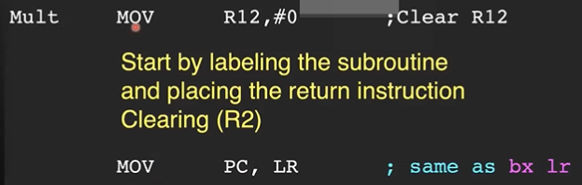

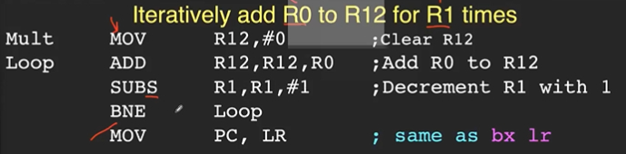

Dot product subroutine:

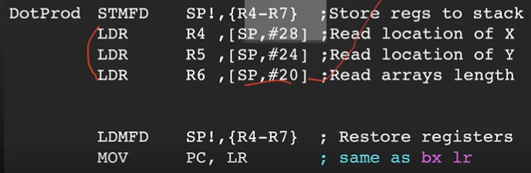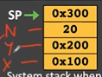

|

|

|/

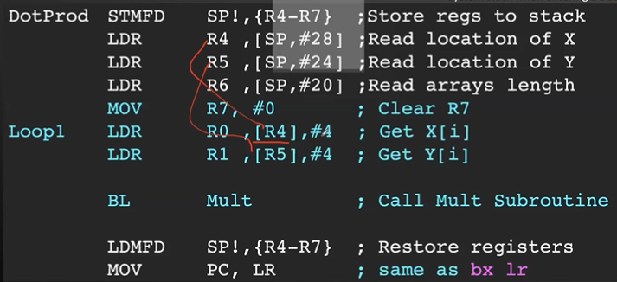

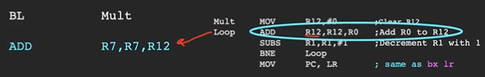

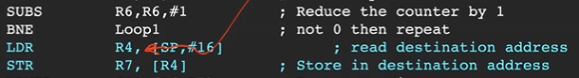

[SP, #16] refers to the address containing 0x300.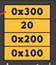



|

|

|/

Now just ensure to push and pop the link registers to SP and from SP. Can also use STMFD or LDMFD.

## Just before any BL instruction:

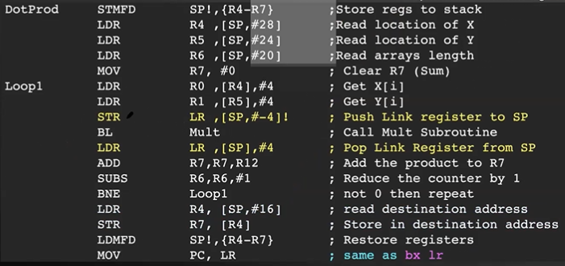

## At the beginning of each subroutine:

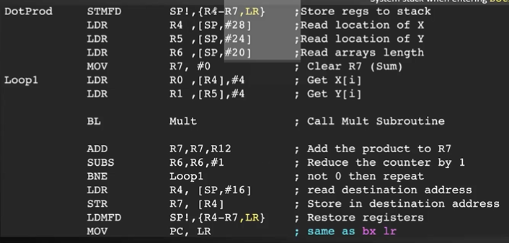

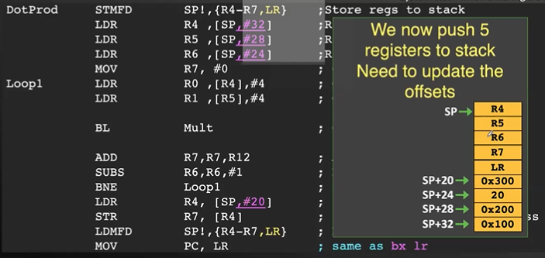

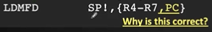

# Recursive Subroutine

## Main problem: some condition must be reached that allows BL Recur to be skipped in order to avoid infinite recursion. Solution:

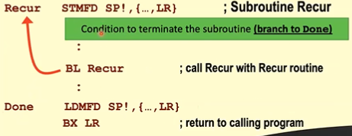

Example: Fibonacci Sequence

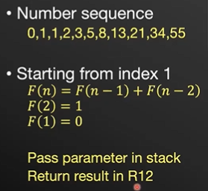

Initialise + exit condition:

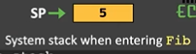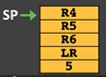

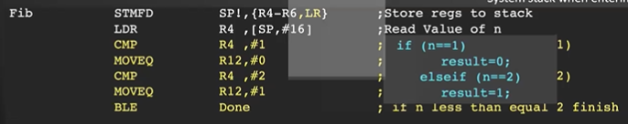

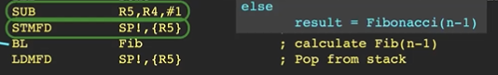

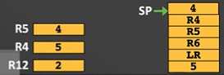

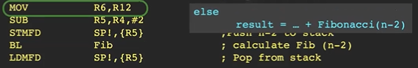



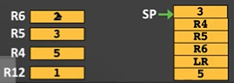--> 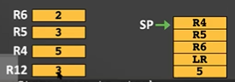



FYI / TRIVIA / PRE-KNOWLEDGE

# Computers: 3 broad categories

## Supercomputer

* Very large, powerful, expensive

## Microcomputers

* Contain microprocessor, external memory and peripheral chip support
* 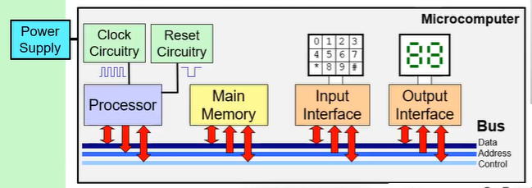

### Clock

* + Most computers are synchronous and are driven by a master/system clock.
  + Speed performance of a computer is governed by the frequency of the clock.
  + CPU requires a fixed number of clock ticks (cycles) to execute instructions
  + Operations closer to the CPU are clocked faster, external components are clocked slower.

### Reset Circuitry

* + Provides an external signal that asserts the reset pin when power is applied
  + Active low-signal on the reset pin for several clock cycles = reset CPU

### Main Memory

* + Most critical part of the computer. Slow access speed = slow PC

### Desktop PC:

* + Motherboard: contains the CPU core
  + PSU
  + RAM
  + Hard disk
  + GPU - where CPU calculations for mesh graphics can be offloaded to
  + I/O peripherals (display, keyboard, mouse)

### Tablet Computer:

* + Motherboard: CPU core, touchscreen driver and controller, power management IC, LCD timing controller, flash memory
    - CPU: package-on-package system-on-a-chip.
      * Package on package is an IC packaging technique that vertically stacks and interconnects separate packages (CPU/memory). This saves space, minimise track length between CPU and memory, allows separate testing of packages, different-sized memory can be coupled with CPU.

## Embedded Systems

* Employs a single-chip microcontroller containing everything

# Harvard and von Neumann Architecture

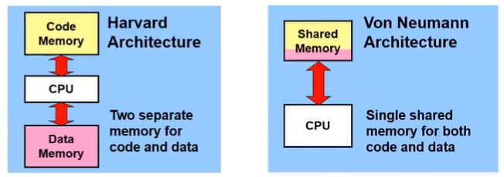

Electronic Numerical Integrator and Calculator (ENIAC): first digital computer based on von Neumann architecture. von Neumann won due to the high cost of memory in the early days of computing:

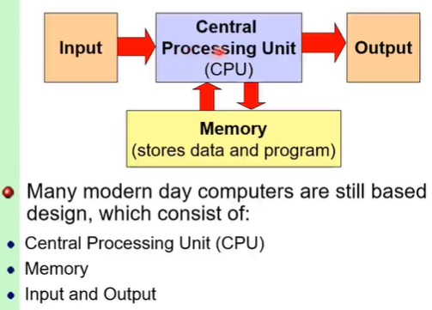

Modern day: mix of both Harvard (separation of data and instructions) and von Neumann (all contents addressable by location)

CZ1106 Lecture TWO:

Data Organisation in Memory

## Programming in Hardware

* Fast computation but very inflexible
* Implementing A=(B+C)xD: 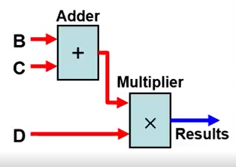

## Programming in Software

* Slower and more complex but easily programmable
* Implementing A=(B+C)xD: 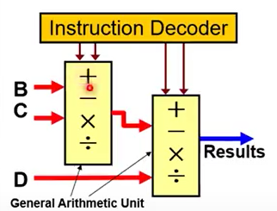
* Code: a sequence of instructions
* Data: values these instructions operate on (e.g. B,C,D)
* Memory: sequential list of addressable storage elements for storing instructions/data
  + 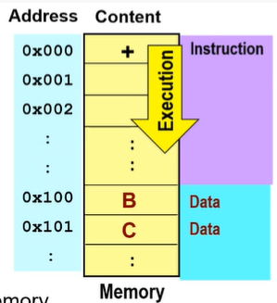

# Memory Hierarchy

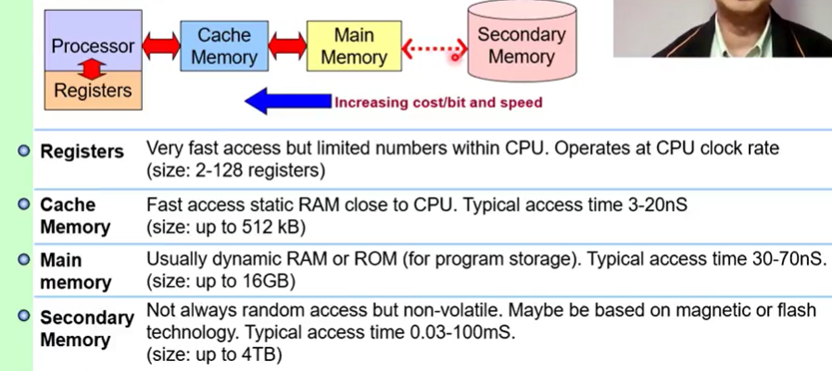

## Main Memory:

* Fix-sized (8-bit) storage location accessible in any order
* Each byte-sized location has a unique address accessed by specifying its binary pattern on the address bus.
  + 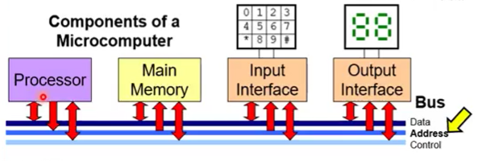
* Memory size is dependent on number of lines (n) in the address bus. Memory size = 2^n bytes.
* von Neumann:
  + Instructions and data are stored in the same memory
  + Contents of memory addressable by location, without regard to data type
  + Execution occurs sequentially unless explicitly modified

## Secondary Memory:

* e.g. SIM card for phone: stores contacts and Network Identification Code to access different networks around the world

# Number Representation

## 2’s complement

* 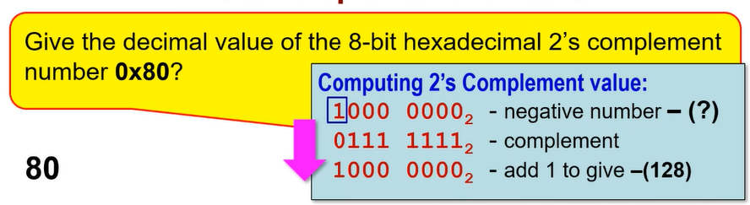

1. Convert the 2’s complement number into binary if not in binary. 0x80 == 1000 0000
2. If the most significant bit (first digit) is 1, the 2c number is negative. 1000 0000 == negative
3. Invert all the numbers (1’s complement). 1000 0000 == 0111 1111
4. Add 1 to the number (2’s complement). 0111 1111 == 1000 0000.
   1. This number is the magnitude.
5. Add back the negative sign.

## Floats

* Floating point numbers are useful for scientific calculations and has issue of trading off precision and range for a given size (in bits)
* Some CPUs make use of an additional floating point unit (FPU) to support floating point computations
* Floats are always signed

# Signed vs unsigned / 2’s complement pt2

* Integers can be signed or unsigned
* Signed are interpreted the same way as 2’s complement - the most significant bit is used for the sign.
  + 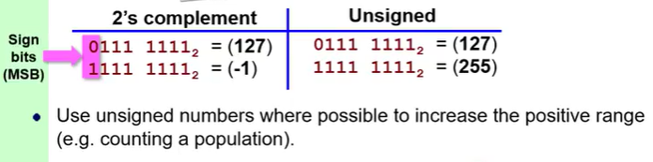
  + For decimal, if the MSB is 0, it is positive. Else, it is negative.
  + For hex, if the MSB is 0-7, it is positive. Else (>=8), it is negative.
    - Reason: convert the hex to decimal. 8 and above means it will start with 1.
* As a result, signed numbers have half the range of unsigned numbers – use unsigned numbers where possible to increase the positive range (e.g. population count)